OPEN ENDED 2

***Q: Which is the leading brand in the Dips & Salsa category?***

***Ans: While TOSTITOS fell in position in Q3 overall it has the biggest market share of all the salsas.***

Reasoning:

--first we create a view with the quarter information for the transactions

WITH quarters as (

  SELECT

    *, strftime('%Y', scan_date) AS year,

    CASE strftime('%m', scan_date)

        WHEN '01' THEN 'Q1'

        WHEN '02' THEN 'Q1'

        WHEN '03' THEN 'Q1'

        WHEN '04' THEN 'Q2'

        WHEN '05' THEN 'Q2'

        WHEN '06' THEN 'Q2'

        WHEN '07' THEN 'Q3'

        WHEN '08' THEN 'Q3'

        WHEN '09' THEN 'Q3'

        WHEN '10' THEN 'Q4'

        WHEN '11' THEN 'Q4'

        WHEN '12' THEN 'Q4'

    END AS quarter

FROM TRANSACTION_TAKEHOME)

--we find the total dollar amount and the quantity bought per category in Dips & Salsa

SELECT p.CATEGORY_3, SUM(q.final_quantity) AS Quantity, SUM(q.final_sale) as USDAmount

from quarters q left JOIN PRODUCTS_TAKEHOME p on q.barcode = p.BARCODE

WHERE p.BARCODE is not NULL and p.category_2 like '%dips%'

– we have to make sure that the products table has a corresponding barcode for the transaction

GROUP by p.category_3

ORDER BY p.CATEGORY_3;

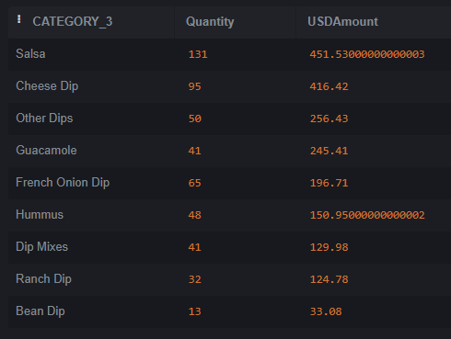

– We can see that people have spent the most money on Salsa

– We can also see that quantity wise Salsa is the most scanned

–With Cheese dips following as a close second

–If we dig into Salsa further

-- investigate the individual brands in the Salsa category

SELECT p.brand, SUM(q.final_quantity) AS Quantity, SUM(q.final_sale) as USDAmount

from quarters q left JOIN PRODUCTS_TAKEHOME p on q.barcode = p.BARCODE

WHERE p.BARCODE is not NULL and p.category_3 like '%salsa%'

GROUP by p.brands

ORDER BY 3 DESC;

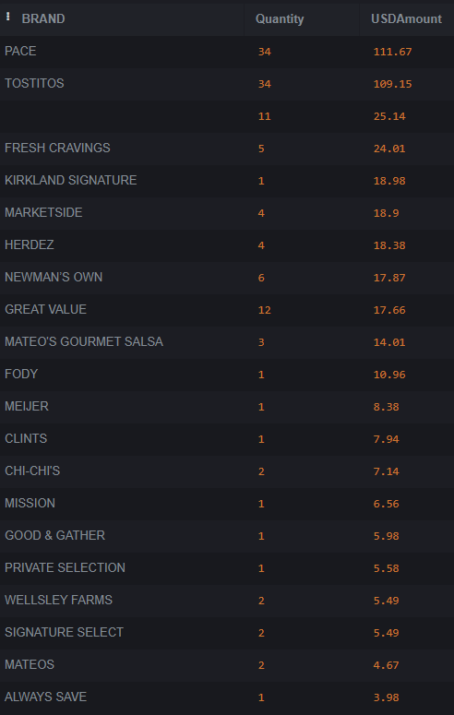– We can see here that PACE and TOSTITOS account for a major chunk of the Salsa sales in both dollar amount and quantity.

https://lh7-rt.googleusercontent.com/docsz/AD_4nXcN-tWf3Kw4M7aLxTRrafGtWA01Ap1-OzGsg4Sw2cWnxOdBTMco5uVH_Bizio7NzjhP7sebIdnOdPLVPE8pFotOHiLdOoWR6D1X5AK2RtJ4JYxr5YKV1AYFLDMwOsX5dzjlhmQ9aFTKCEvUYKwh8KybHoU?key=aLoaVjfqzBC9dLEtWtLBNw

–We can now further delve into the Salsa purchasing patterns per quarter

SELECT q.quarter, p.BRAND, SUM(q.final_quantity) AS Quantity, SUM(q.final_sale) as USDAmount

from quarters q left JOIN PRODUCTS_TAKEHOME p on q.barcode = p.BARCODE

WHERE p.BARCODE is not NULL and p.category_3 like '%salsa%'

GROUP by q.quarter,p.BRAND

ORDER BY USDAmount;

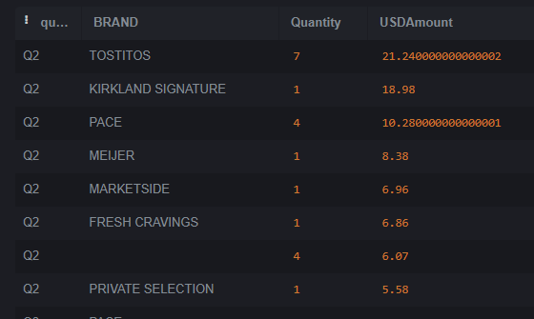

Q2: Top brand is Tostitos

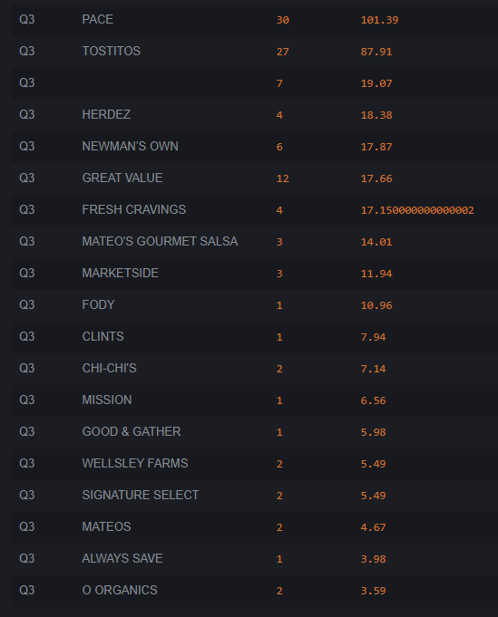Q3: Top Brand is Pace

– We need to see which brand performed over both quarters

–Note: as I am using SQLite it does not support window functions

quarterly_total AS(

SELECT q.quarter, sum(q.final_sale) As quartertotal

FROM quarters q left JOIN PRODUCTS_TAKEHOME p on q.barcode = p.BARCODE

WHERE p.BARCODE is not NULL and p.category_3 like '%salsa%'

   GROUP by q.quarter

),

transaction_total As (

SELECT *

from quarters q inner JOIN quarterly_total t on q.quarter = t.quarter

)

SELECT t.quarter, p.BRAND, SUM(t.final_sale) as USDAmount, SUM(t.final_sale)/(t.quartertotal)*100 AS PercentageSale

from transaction_total t left JOIN PRODUCTS_TAKEHOME p on t.barcode = p.BARCODE

WHERE p.BARCODE is not NULL and p.category_3 like '%salsa%'

GROUP by t.quarter,p.BRAND

ORDER BY t.quarter, USDAmount DESC;

–While PACE outperformed TOSTITOS in Q3, in Q2 TOSTITOS was leading PACE by a smaller margin.

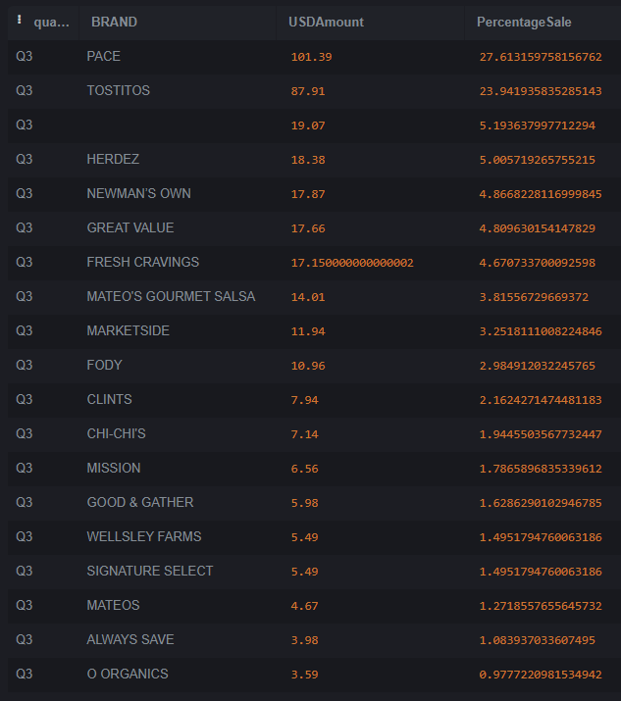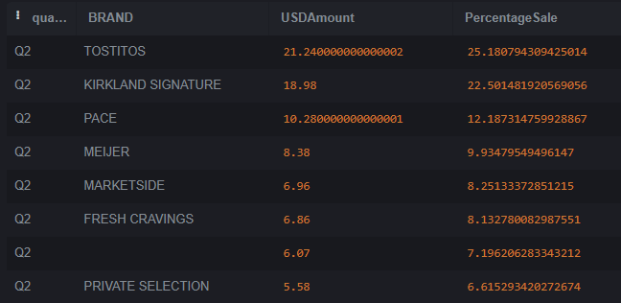

Visualisations

